1.**Introduction**

EduConnect is an integrated platform connecting different groups like the schools, colleges, students and organizations in the education ecosystem, in other words, the service providers and consumers of education with each other.

* 1. **Overview**

We work with a mission to support India attain its education goals in terms of quality, technology, skill development and innovation, and revolutionize the way India learns, works and lives.

* 1. **Purpose**

We are a pioneer in bringing the two ends together for networking and exchange of ideas ensuring seamless flow of information about best possible ways education can be imparted in India.

2 . **Problem definition and Design thinking**

2.1 **Empathy map**

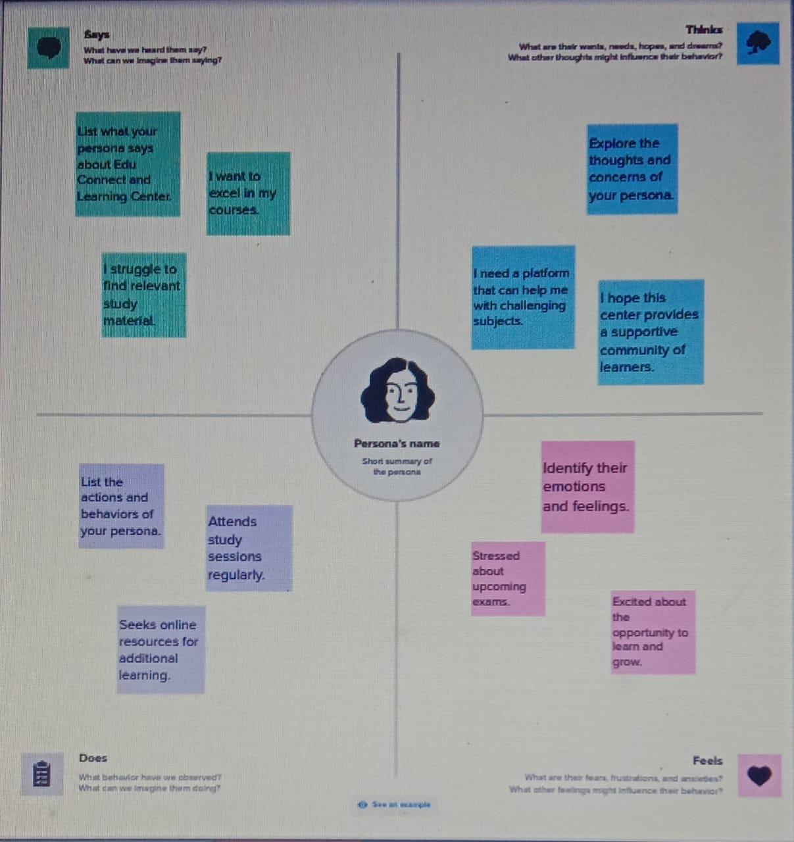

**2.2 Brainstorm;**

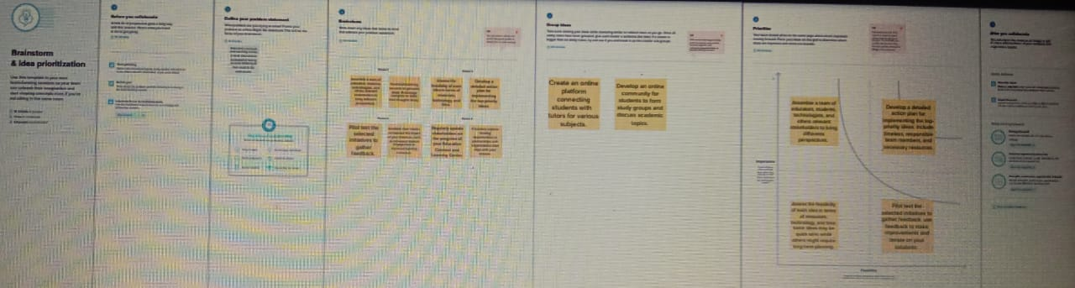

**3. Advantages and Disadvantages:**

**‘Educonnect Language Connects’, a user-friendly English communication enhancement program, has been designed by a team of educational researchers from Educomp Solutions Ltd. For the masses who wish to fulfill their dream of fluent communication in English.**

The bilingual approach used in ‘Educonnect Language Connects’ makes it a self-paced learning program that helps learners to relate the known (in their own language) to the unknown (in the English language) with ease.

The content is delivered through 22 audio visual modules that help learners to acquire correct contextual vocabulary, pronunciation and meaning of the content independently. Every module has four sessions, each focusing on the concept word, its pronunciation, meaning and usage.

4.**Source code**

**https://github.com/rajalakshmipalanivel/_**

**5.Conclusion**

The program had been successfully executed.